The Zones of Regulation
A Guide for Parents
At The Grove School, we use The Zones of Regulation to teach and support our children. The Zones teaches a variety of social-emotional skills to children, starting with early emotional skills and advancing on to self-regulation and navigating social situations.
The Zones of Regulation categorise our physical and emotional feelings into four, clear, coloured, zones which pupils can easily identify.
It is a visual and structured curriculum that teaches children to develop their understanding of emotions in themselves and in others, to understand how their emotions and behaviours impact everybody around them and they learn which tools they can use to support and manage their feelings.
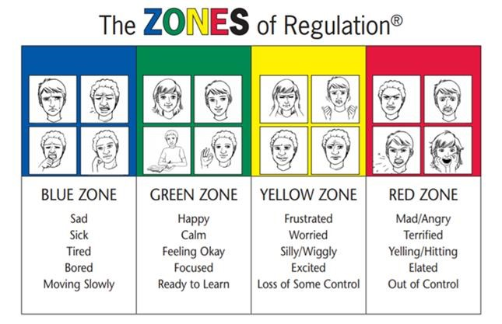
As with everything we do, we meet the children at the level that is most appropriate for them and in an individual manner that best suits their individual needs.

Why do we use Zones?
To teach the children how:
- to identify which zone ‘you’ are in.
- to recognise and communicate the different zones.
- to learn tools to stay in or move between zones.
- to identify their feelings as well as read others’ facial expressions.
- to understand how their behaviours can influence others’ thoughts, feelings and behaviours.
- to regulate their own feelings and in doing so, develop their own ‘toolbox’ of strategies to self-manage their bodies, thoughts and emotions.
- to control emotions/impulses, manage sensory needs and improve problem-solving skills.

The Blue Zone
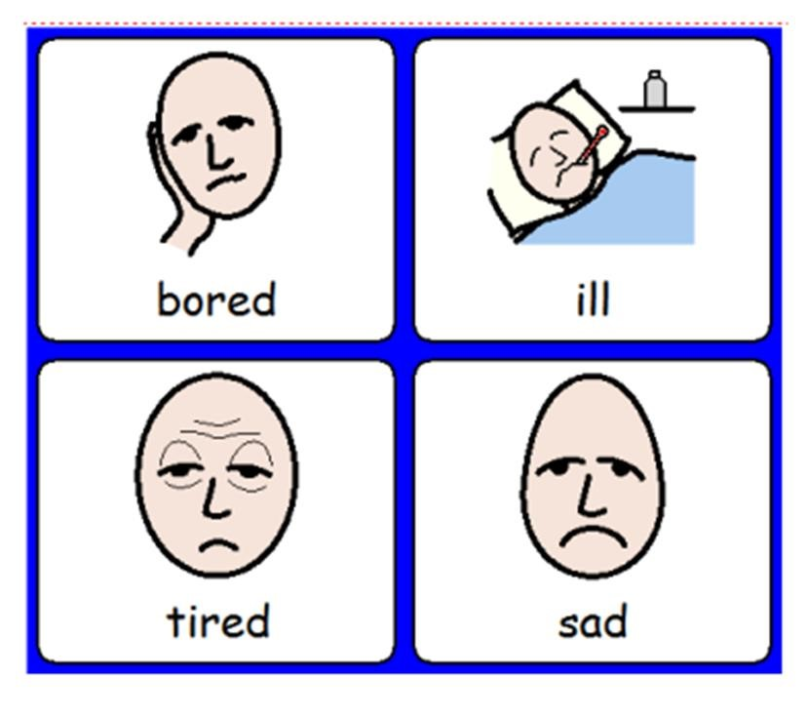
The Blue Zone is used when a person is feeling low states of alertness or arousal.
When you are in the blue zone you may be feeling down – sad, sick, tired, or bored. You are still in control, but with low energy.

The Green Zone
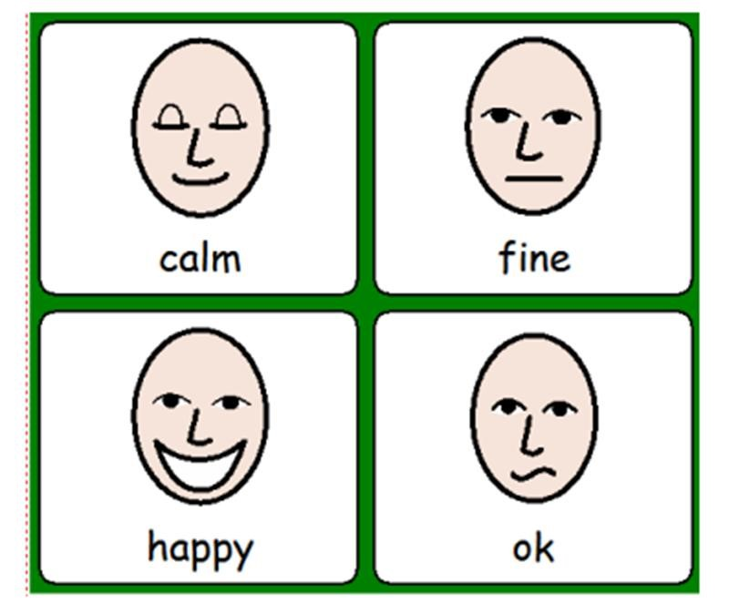
The Green Zone is used to describe a calm state of alertness.
A person may be described as happy, focused, content, or ready to learn when in the Green Zone.
This is the zone where optimal learning occurs.

* We do not expect the children to always be in the Green Zone. Similarly the adults in school will not model always being in Green Zone, All zones are appropriate in different situations.*
The Yellow Zone
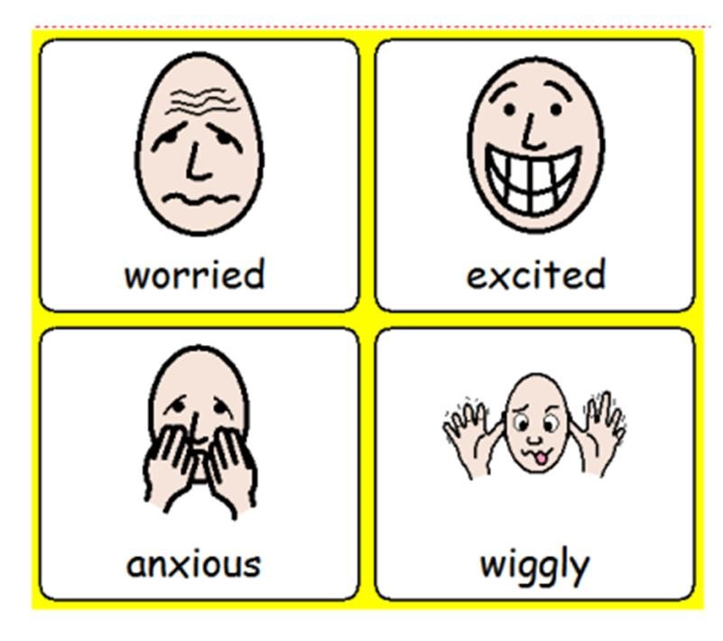
The Yellow Zone is also used to describe a heightened state of alertness and elevated emotions.
However, the child still has control over their emotions.
A person may be experiencing stress, frustration, anxiety, excitement, silliness, the wiggles or nervousness when in the Yellow Zone.

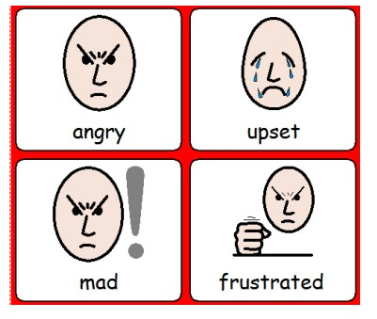
The Red Zone
The Red Zone is used to describe extremely heightened states of alertness and intense emotions. A child may not have control over their own emotions or behaviour if they are in the Red Zone.
A child may be elated or experiencing feelings of anger, terror, frustration etc.
These are perfectly normal to feel but what matters is how children learn to regulate and manage these strong feelings.
*It is important to remember…the Red Zone is not a bad zone! None of the zones are bad they are all equal and neutral.*

How can you use zones at home?

Every pupil will need a different set of tools that calm or alert them so they can get back to their green zone – that relate to their age, hobbies, interests and personal preferences. Here are a few ideas:
Communication tools:
- reduce demands
- reduce use of language
- model calm behaviour and voices
- use positive reinforcement
- give choices
- use visual tools
- use countdown timer
- have a consistent daily routine
- use verbal redirection and prompting
- identify your own feelings using Zones language in front of your child (e.g. “I’m frustrated. I think I am in the Yellow Zone.”)
- talk about what tool you will use to be in the appropriate Zone (e.g. “I need to take four deep breaths to help get me back to the Green Zone.”)
- ask “What would help you right now?” You could say “it makes sense you feel….”
Sensory tools & movement breaks:
- Hugs
- rock them calmly
- a snack
- a drink
- fidget toys
- exercise, ball games, runs/walks, yoga, climbing or other movement breaks
- a creative break, for example colouring/drawing/building
- a quiet space
- headphones
- music
- breathing exercises
- a joint activity they are good at such as baking
- walking at pet
Thinking tools:
- size the problem
- positive self-talk
- discussion of problem with adults/peers
- use creative visualisation think about your favourite place or something that makes you laugh
- count down slowly and quietly together from 10
Environmental changes:
- set up opportunities for success
- turn down lights
- change seating arrangements
- temperature of room
- noises in room
- have a relaxation corner
- remove an audience
- change of people in environment
- having friends over
- fresh air
- put up and reference the Zones visuals and tools in your home
- praise and encourage your child when they share which ‘Zone’ they are in
*The zones of regulation teaches children and young people that all zones are natural to experience and it is okay and acceptable not to be in the green zone. We all experience multiple, (if not all four!) zones every day and can be in more than one zone at the same time.*
