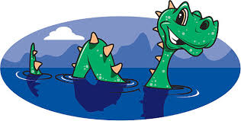

Thinking skills – MAPP and B-Squared

We will be working on our individual B-Squared targets for Reading, Writing and Maths.

• We will deepen our knowledge of Landmarks around Great Britain and learn basic facts about human and physical features.

• We will incorporate Science, Computing, Art/ DT, Music and Geography/ History throughout the topic in our planned themed activities.

**Communication – MAPP and B-Squared**

We will be following our personalised MAPP targets for Communication

• We will be developing our chosen communication methods to direct, ask for and interact with both adults and peers.

• We will develop our speaking and listening skills throughout the day.

• We will be listening to and actively engaging in stories, non-fiction, rhymes, and poems, sharing our ideas, and developing both our language and vocabulary.

**

**Sensory/Physical**

• We will complete our Physiotherapy programmes daily. We will complete our swing programmes and OT activities as advised by the OT therapist.

• We will use a range of sensory experiences that engage all the five senses to develop our learning.

We will develop our fine and gross motor skills through a variety of play opportunities.

**Songs/ Stories/ Music/ Videos**

* London Bridge is falling down - [London Bridge Is Falling Down Nursery Rhymes Popular Baby Songs - YouTube](https://www.youtube.com/watch?v=0-Y7Qi3fMs0)
* The Story of the Giant’s Causeway 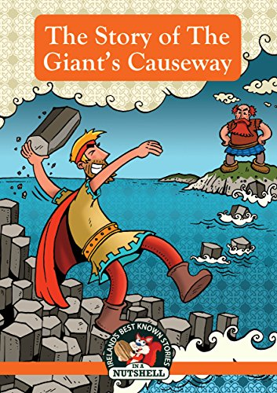
* No Such Thing as Nessie. Text

  Description automatically generated
* The Queen’s Knickers. Diagram

  Description automatically generated with medium confidence

**PHSE**

• We will be developing our positive sense of self and developing confidence in our own abilities. • Through adult modelling and guidance, we will learn about how to look after our bodies, including healthy eating and managing personal needs independently. • Through supported interaction with other children, we will develop our social skills and turn-taking abilities. This will be achieved by planned group games and activities, circle time, morning and afternoon registration and a variety of activities to promote working collaboratively. • We will learn how to make good friendships and how to co-operate with one another. • We will develop our independence in our learning by taking responsibility to find the equipment/ resources that we will need for the activity. • We will be developing our strategies for managing our emotions using the Zones of Regulation

**Landmarks of Great Britain.**