**Sycamore Class Activity Suggestions (all optional and to be adapted to suit you and your child)**

**Online Music for Singing and Dancing**

**Check out these youtube channels -**

* The Learning Station
* Singing Walrus
* KiddieOK
* Cbeebies songs
* Barefoot books
* Dream English Kids
* MelodySigns (she sings and signs Makaton)

**We did a friendship theme recently, and we would always keep reminding our pupils about the values of friendship (kindness, sharing, taking turns, helping, etc). Just google these –**

* Make New Friends – Learning Station
* Let’s be Friends – London Rhymes
* The More We Get Together – Learning Station
* Friends song – Singing Walrus
* CBeebies Friendship song
* Preschool Learn to Dance: Make New Friends
* Being a friend singalong from kiddieok (check out their other songs too)
* Song – Forever friends SS

**This week is anti-bullying week.** Here is the link to the website for resources -<https://www.anti-bullyingalliance.org.uk/anti-bullying-week>

Watch and listen to the song – ‘The Kids are United’ on youtube – by searching for - ***Andy and the Odd Socks - The Kids are United (Official Video) ft. Princess K, Libera***

We were planning some cross-curricular learning. You can opt in or out of these –

**Links to literacy** – words relating to friendship.

**Links to music/dance/role play** – joining in with the video and playing air guitar!!

**Links to art and design** – making our own guitars and graffiti art

**TV programmes and websites which support our learning**

* **Sesame Street –** we recently watched a Sesame Street video to help us learn about ‘conflict’. There are many other Sesame Street videos to help teach about emotions. E.g., Check out the video about ‘empathy’.
* **CBeebies** is great for Makaton with Mr Tumble and almost any other topic or subject. Again just do a google search.
* **Helpkidzlearn -** [**https://www.helpkidzlearn.com/updates/school-closure.html**](https://www.helpkidzlearn.com/updates/school-closure.html)They are doing a 14 day free trial. We use the games and activities with all our pupils in Sycamore Class. There is something for everyone. Some favourites! We also use Readymadeboards which has a range of topics for skills practice.



**Sensory play and Role Play**

**Water play** Sycamore class boys love water play. You won’t have a water table at home but you can get your boy to do the washing up, or splash in puddles in the garden (full waterproofs on!!) or have fun in the bath. Do you have a foot spa? Put a tiny squirt of bubble bath or washing up liquid in it with water and you’ll create a bubble mountain. Beware of the floods! Have towels handy ;-)

**Mirror time** - Some of our boys love watching themselves in the mirror. If your son enjoys blowing bubbles then get him to blow bubbles to his reflection in the mirror. Dressing up fun could be combined with this. Let you son try on whatever you can find (hats, wigs, jewellery, masks) and let him admire his ‘look’ in the mirror! You could combine this with face painting/make up if you are feeling creative! Send me photos ☺

**Story telling role play** – role play a favourite book such as ‘The Tiger Who Came to Tea’. You could combine this story with playdough cookie making or actual baking. You could make a tiger face mask. What are your favourite books at home? Enjoy sharing stories with your son.

**Messy Play** – food ‘messy’ play – spaghetti, jelly, gloopy corn flour and water. Some of the boys like exploring different textures with their hands, or getting some ‘bits n pieces’ out of the kitchen cupboards and playing at cooking.

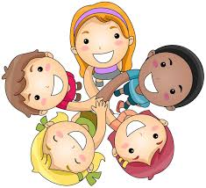

**Functional skills to practice**

**Some of our boys love to be chefs and most like to eat treats! This list can be adapted to suit you and your son. No pressure!!**

**Practicing using a knife** – cutting soft fruits or toast with a normal knife (rather than a sharp one!). Spreading toast.

**Practicing using scissors** – e.g., cutting out shapes to combine with maths.

**Motor skills generally** – e.g., using a spoon to mix. Anything that’s using their hands to hold and use, for example, a utensil, a pen, paint brush.

**Maths combined with cookery** – weighing ingredients; setting a timer;

**Maths combined with exercises** – how many star jumps can you do in 2 minutes? How long will it take you to run round the garden? How far can you jump? How many jumps will it take for you to jump from here to here?

**Counting skills and setting the table** – e.g., get 5 cups from the cupboard.

**Reading -** reading a simple recipe or a shopping list.

**Writing, drawing or scribbling –** anything goes! Using chalk outside to draw pictures in a yard. Draw anything and send me a picture ☺ Others could practice writing their names. Maybe even their address. Those that have PECS folders could practice naming their friends from school, and writing their names too. You can judge what your son would be able to try.

**Any practical tasks to help in the house/garden** – e.g., loading/empting the washing machine; doing the recycling; hanging up washing; sweeping up; vacuum cleaning; feeding the birds (and watching them feed).

**Getting moving and/or fresh air!**

**Gym ball workout -** if you don’t have one already (haha!! ) get a gym ball or a spacehopper for your son’s daily workout! ☺

**Obstacle course in the garden** – for those who have outdoor space, use whatever you can find to create a simple or challenging obstacle course, depending on the skills/confidence of your child.

**Dress for the weather** – even if it’s raining or windy, I bet your son would love to be outside to play so just get layered up and out there! Blow those cobwebs away! Splash in puddles and let them get wet!!

**Treasure Hunt** – hide 10 things in the garden (or house) for them to find.

**Trampolining** – we were donated a small trampoline for class and it’s been a huge success, especially since we can’t use soft play. All the kids love having a bounce on it.

****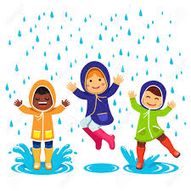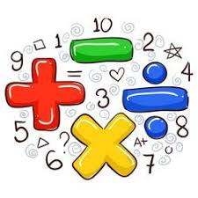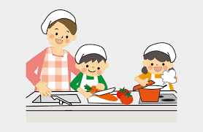

**Yoga and Self-Care for Parents and Children**

This is on ‘*Healthflix*’ online . Do a google search for *‘Self care for parents and children with special and additional needs’* or click on this link

<https://www.youtube.com/watch?v=mOREF2ZYIPw>

I am doing a yoga training course to use yoga with children with special needs. The course leader is called Jyoti and in this video link she talks you through some self-care methods.