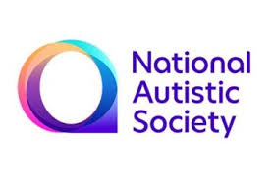

Autism and Eating Challenges
Date: Wednesday 23rd June 2021 10.00 am - 12.00 pm
Online webinar for parents/carers
Presented by:
Dr Gillian Harris, Consultant Clinical Psychologist
Sarah Mason, Speech and Language Therapist
Birmingham Food Refusal Services
Come and join our webinar for parents of children and adolescents with autism who are difficult to feed. You will learn how children normally learn to eat, why some children refuse foods and what you can do to help them. You will learn about Avoidant and Restrictive Food Intake Disorder (ARFID).
Your tutors are Dr Gillian Harris and Sarah Mason who have over 50 years combined experience of working in the field of childhood feeding and eating disorders.
If you would like to join us, please book your place by emailing Helen Sutherland at: NasNorthNothumberlandBranch@nas.org.uk

