Beech Class Mini-Project
A Whale’s Tale – Oceans/Recycling/Cooperation
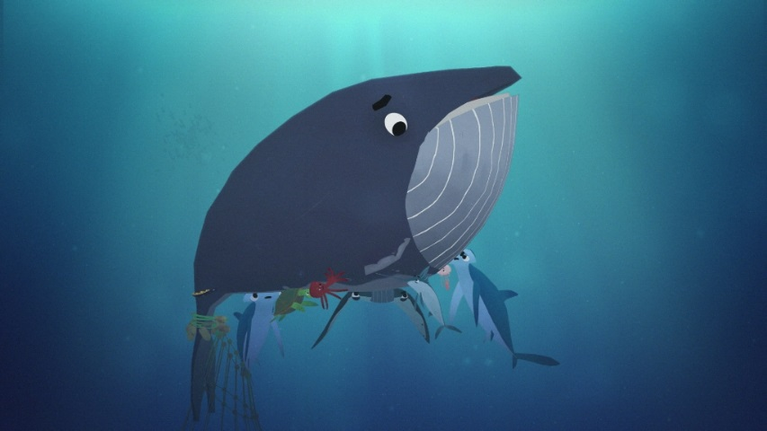
Start by watching ‘A Whale’s Tale’ by Hopeworks, available on Youtube.
Then complete any of the following activities:
- find out the name of the 5 oceans O
- make a poster warning people plastic waste in the oceans R
- look up the tide times for your local beach and notice how they change every day O
- help your family by taking on a helpful job around the house. Think about the jobs you do in class for your weekly class jobs. Can you do something similar? C
- find out about one of the ocean animals you see in the short film. Draw it and find out then write down 5 facts about it O
- make a boat that can float from junk and waste materials you would otherwise throw away. Can it hold a Lego Person? R
- find out 5 interesting facts about the ocean O
- carry out a random act of kindness everyday C
- find 5 things in your house that will float and 5 things that will sink (check with an adult first before trying) O
- record what you put in your recycle bin over a week. What is the most popular item? R
- find out 3 different plants that grow in the ocean O
- make your own snack and drink once a day. Remember to tidy up afterwards! C
- also remember you can do Busythings on school360.
You can email me (lee.waugh@thegrove.northumberland.sch.uk) some of your work, if you would like, or show me when we get back to school.
See you all soon,
Miss Waugh

